Nick Forleo

SWENG 837

1. Using the “Representing Object Relationships as Tables” pattern, develop a series of communication diagrams to obtain the patient’s information

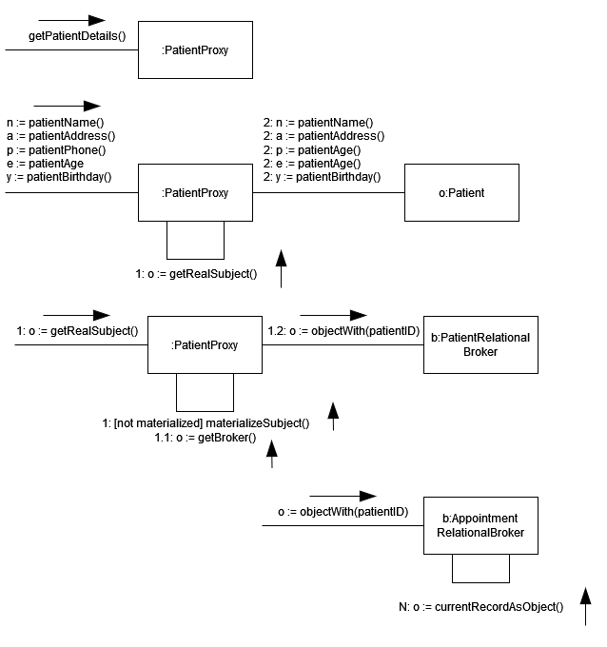

1. Using the “Complex Object Instantiation” pattern, develop a series of communication diagrams to obtain the patient’s all the appointment records.

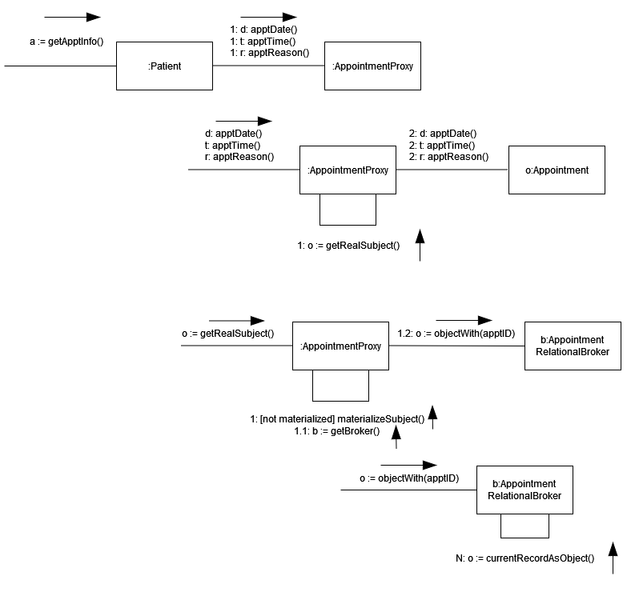

1. Reference Info